**HTML**

- Hypertext Markup language

- Written by Tim Berners-Lee in 1993

- latest version HTML 5

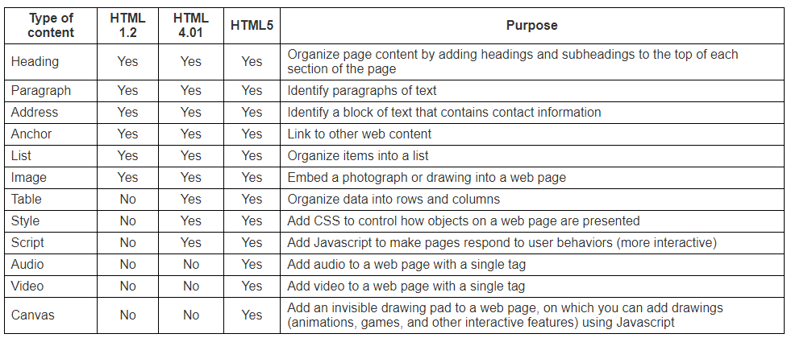

* HTML describes the structure of a Web page
* HTML consists of a series of elements
* HTML elements tell the browser how to display the content